PROJECT REPORT
Team Members
MADHAN K (TL)
ANANDHA NARAYANAN T
HARI HARA SUTHAN R
DINESH KARTHICK K
Project Title
- Control LEDs using an Arduino Uno and simulate different LED patterns and colors using the Wokwi Simulator
Objectives
- To understand the basics of digital output using an Arduino Uno.
- To control multiple LEDs using microcontroller-based programming.
- To simulate various LED blinking patterns.
- To use the Wokwi simulator for hardware simulation and testing.
Description
This project focuses on creating multiple LED patterns using an Arduino Uno. The LEDs are connected to different digital pins and programmed using C/C++ through the Arduino IDE. The project is simulated using the Wokwi simulator, allowing virtual testing without physical hardware.
Scope & Features
- Simulates basic and complex LED patterns.
- Demonstrates loops, delays, and logic.
- Provides foundation for microcontroller outputs.
- No hardware required during testing.
System Requirements
Inputs : Digital signals from Arduino.
Outputs : Visual LED patterns.

Hardware Requirements
- Arduino UNO
- Breadboard (Simulated)
- Resistors (220 ohm)
- LEDs (Various Colors)
Software Requirements
- Arduino IDE
- Wokwi Simulator (https://wokwi.com)
Knowledge Required
- Basics of embedded systems
- Arduino programming in C/C++
- Digital electronics concepts
Skill Required
- Circuit simulation
- Logical thinking and pattern design
- Debugging code

Setup Steps
1. Open https://wokwi.com and start a new Arduino Uno project.
2. Connect 5 LEDs to digital pins (2-6) using resistors.
3. Paste the code into the Arduino editor.
4. Simulate and test all patterns.
5. Observe the LED behavior and debug as necessary.

Project Architecture Submission

Block Diagram
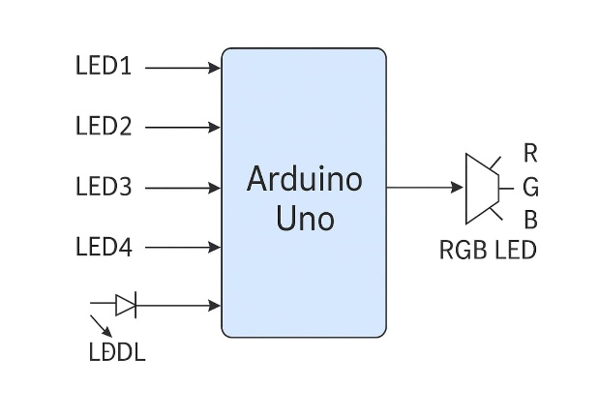
Circuit Diagram
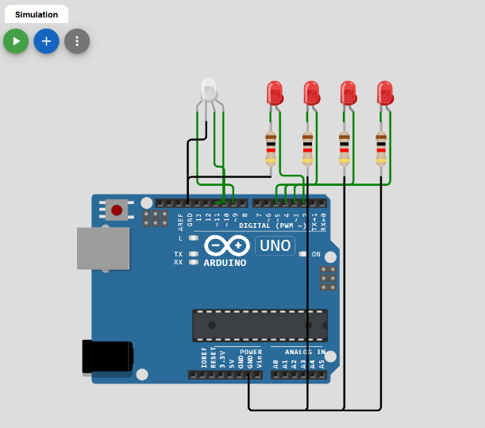

Code
int leds[] = {2, 3, 4, 5};
int redPin = 9;
int greenPin = 10;
int bluePin = 11;
void setup()
{
for (int i = 0; i < 4; i++)
{
pinMode(leds[i], OUTPUT);
}
pinMode(redPin, OUTPUT);
pinMode(greenPin, OUTPUT);
pinMode(bluePin, OUTPUT);
}
void loop()
{
for (int i = 0; i < 4; i++)
{
digitalWrite(leds[i], HIGH);
delay(100);
digitalWrite(leds[i], LOW);
}
setColor(255, 0, 0); delay(500);
setColor(0, 255, 0); delay(500);
setColor(0, 0, 255); delay(500);
}
void setColor(int red, int green, int blue)
{
analogWrite(redPin, red);
analogWrite(greenPin, green);
analogWrite(bluePin, blue);
}

Test Case Wise Result

Test No | Description | Result
1 | All LEDs working | Passed
2 | Blink pattern | Successful
3 | Chasing pattern | Successful
4 | Alternate pattern | Successful

GitHub Repository
[https://github.com/Madhan-03/control-leds]
Final Project Video
[https://drive.google.com/file/d/1zp6CoboG_tJeI3HSAcV344OcsT6VlXCd/view?usp=sharing]

Submitted By :
MADHAN K (TL)

